The Alphabet Book

By: Zoe Schucknecht

I would like to dedicate this book to Catharine (My first grade buddy). She inspired me to write this book. Thanks Catharine, you are great.

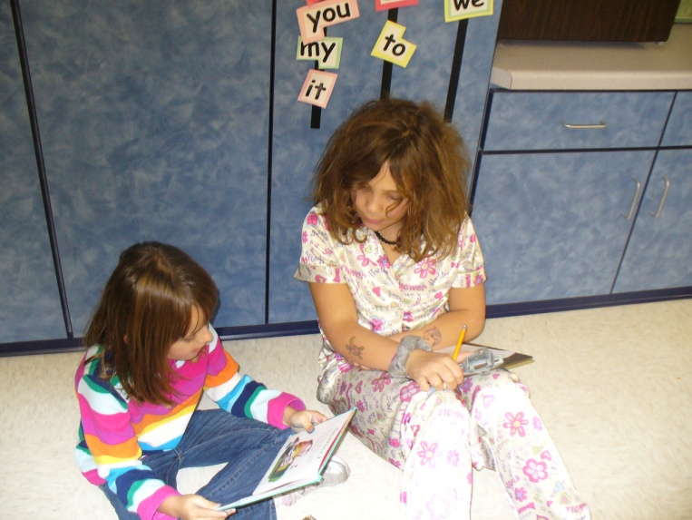

Now then can we get this book started?
Turn the page and we can start reading:
My Alphabet Book.
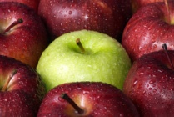
A Is for an awesome apple

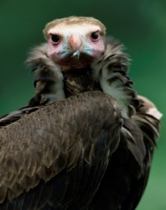
B is for a bad bird


C is for a crazy Cola can


D is for dude named Devin

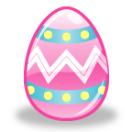

E is for an enormous egg

F is for a fabolous flute

G is for a giant gate

H is for a hot house

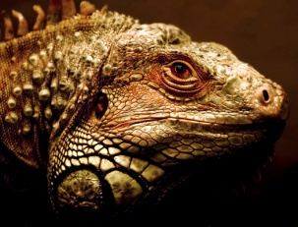
I is for an ickey iguana


J is for a jam jar

K is for a kind kite

L is for licking lion

M is for my mittens

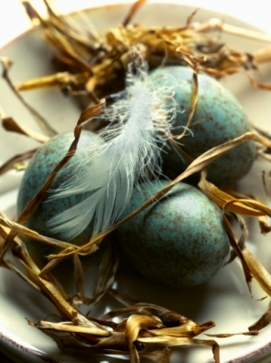

N is for a new nest



O is for on okay

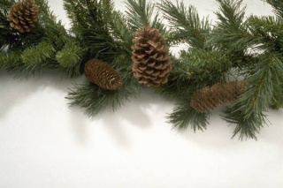
P is for picky pines

Q is forquieting down quietly

R is for rusty rain

S is for super singing


T is for a talking tv

U is for a unicorn umbrella

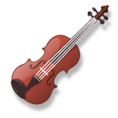
V is for a very nice violin

W is for wicky-wacky wagon


X is for x-ray

Y is for yellow yarn

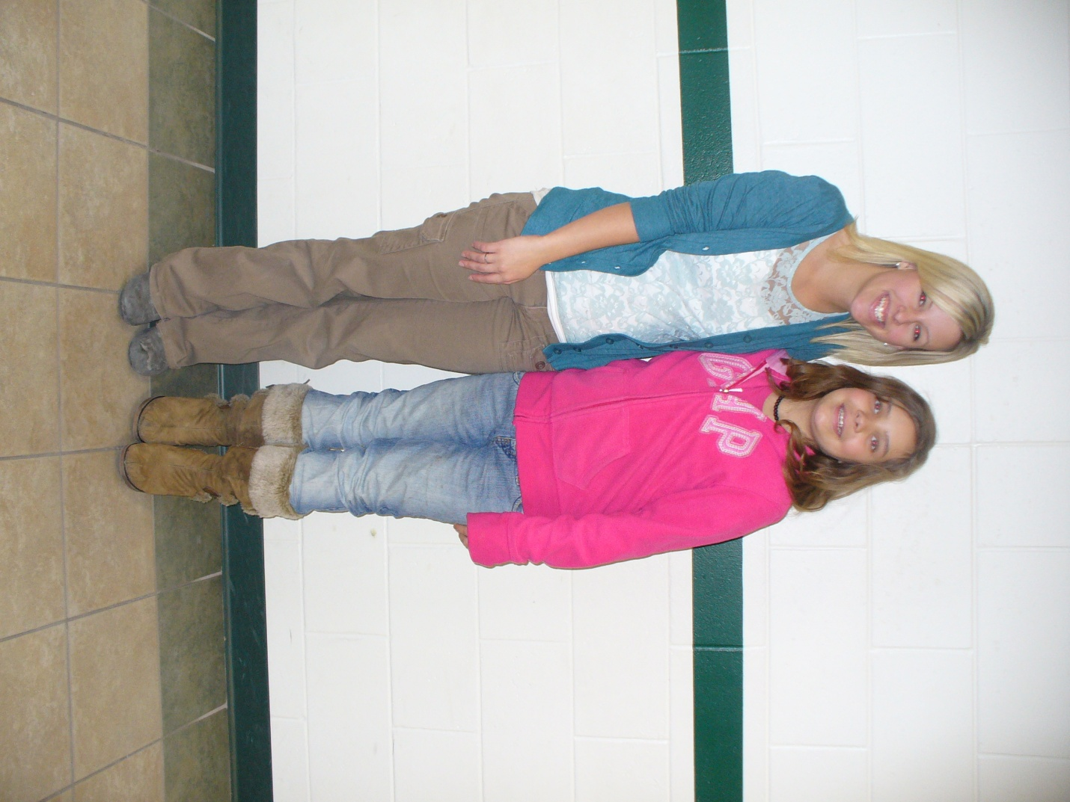
Z is for… Zoe

